1-

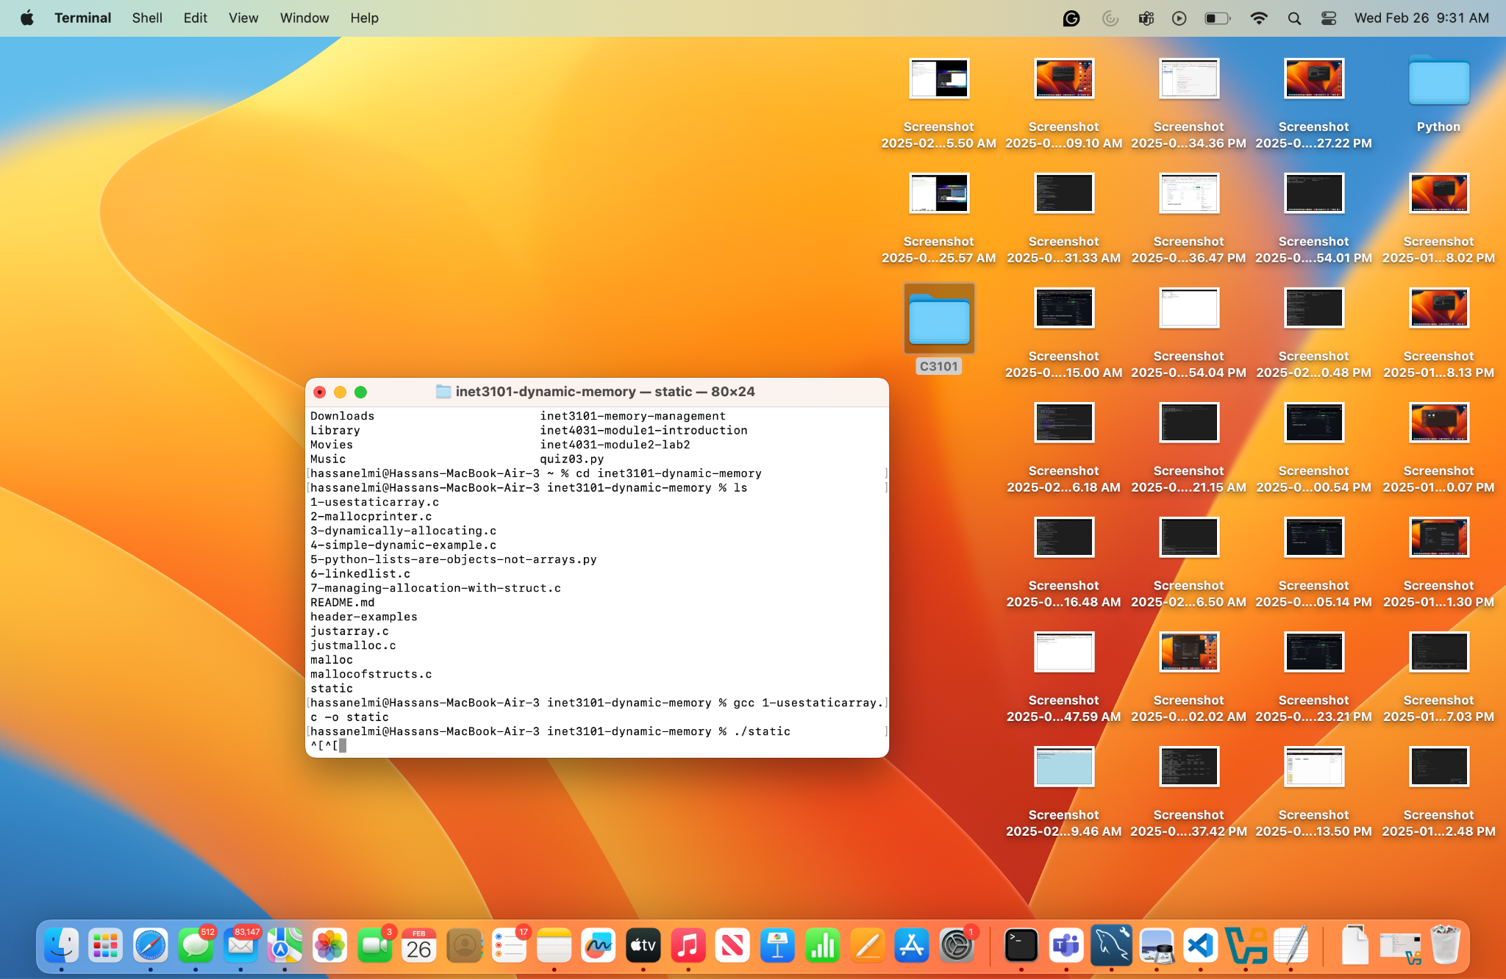

3- My approach to resizing an array started with using the resources that were provided at the bottom of the file and some explaining from the co-pilot. From what I could understand It starts by allocating an initial amount of memory based on user input, then using a while loop to prompt the user to enter numbers until they enter -1 to stop. As inputs are being entered, the array has to be checked if it is full and if it is full realloc() is meant to double the size of the array, which makes sure there's always enough space for new numbers while also keeping the old data. There is also a counter to keep track of the number of inputs and when the user stops the numbers stored in the array are printed. Lastly free() like mentioned in the comment freed up memory at the end. Allocated memory isn't automatically freed up by the OS like an C Array.

4-

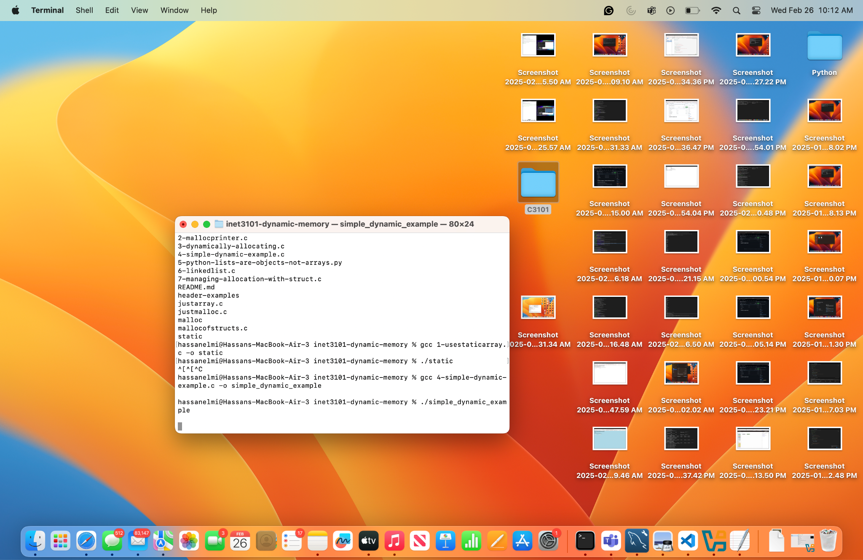

5-

In Object-Oriented Programming an object is an instance of a class that combines attributes and methods. Each object has a unique identity and behaviors determined by its methods. Objects interact with each other in a program, making code maintainable by following principles.

6-

A linked list helps with dynamic memory by storing data in separate memory locations instead of needing one big block like an array. Each piece of data is connected using pointers, making it easy to add or remove items without shifting everything around. This makes linked lists useful when memory is limited or constantly changing.

Header - 